Lesson Plan: Bias Analysis of a Text Book Section on Lactose Intolerance
Where in the Unit Sequence: Week 1: Lesson 3
Duration of Lesson: (1-2) 40 minute periods
Objective: To learn the types of biases that are in science informational texts and to see how society has portrayed lactose intolerance in a biased way. To identify problems and issues students or people they know have faced because of this biased portrayal of lactose intolerance in society.
Key Content: Science texts often are biased because they reflect the biases of the people who wrote them and they reflect the biases in the larger society we live in. Lactose intolerance is portrayed by society and in biology text books as a disorder that affects some people. Dairy products are portrayed as essential for health.
Key Vocabulary: Lactose intolerance, bias, invisibility, fragmentation, stereotyping, imbalance, selectivity, cosmetic bias, unreality, linguistic bias
Key Skill (Standards).
CCSS.ELA. 2.8. Evaluating arguments and claims.
CVSS.ELA. 2.9. Acquire and use academic vocabulary

Detailed Facilitation Teacher will do… Teacher will facilitate students breaking into groups to learning about types of bias critically examine a text book section on lactose intolerance to uncover the hidden bias in it. Teacher will then facilitate a discussion about bias in text books and society and to stimulate students toward generating ideas they have about what the issues and problems are that bias about lactose intolerance has caused for them and others they know. The teacher will record this list on chart paper, so more ideas can be added.
Detailed Activities Students will do: Students work in groups to apply the concepts of bias to critically examine a text book paragraph on lactose intolerance. They record their findings on chart paper and present to the class. They participate in a discussion about the bias they uncovered and its consequences for them.
Assessment: Teacher observation of student participation in the group work, Teacher assessment by observation of how well individual students are using academic vocabulary in their discussions.
Resources needed: handout of forms of bias and text book section, “Got Milk?”, chart paper, and markers.
Homework: Students should look around their communities, including their school for evidence of bias and issues and problems associated with it about lactose intolerance.
Teacher Notes: Go over the different types of bias with the students; have them work in groups to read the paragraph, “Got Milk?”, analyze it for bias; and write down what they have uncovered. Have each group present their findings. Lead a discussion of why text books are biased and how they reflect the writers and the societal bias. Keep track of questions students have and save them for further research and learning. As a group, generate a list of issues that may be the consequences of this bias. Essential Questions for the discussion: How is this text book section biased and how does this reflect society?
Essential Questions for the Discussion:
- How is the text book biased?
- How does the text book bias reflect the bias in society?
- What are the consequences of this bias for people?
Bias Analysis of a Text Book Paragraph
Directions: Read through the text book paragraph with your group. Analyze it for bias and record your findings on chart paper. Each group will present your ideas on how you think it might be biased and the reasons.
Look for the following kinds of bias:
a. Invisibility: Are particular ethnic groups not included in the narrative?
b. Stereotyping: Assigning characteristics to all members of a group.
c. Imbalance and Selectivity: Presenting only one interpretation of a situation and omitting other perspectives.
d. Unreality: Glossing over unpleasant facts and events and painting a rosy picture of a situation.
e. Fragmentation and Isolation: When a particular group of people is presented in an isolated way, only interacting with persons like themselves, on the side, rather than a main part of society.
f. Linguistic Bias: Language that that denies the existence of different groups, or portrays particular groups negatively.
g. Cosmetic Bias: Attractive illustrations or photos that presents a favorable false impression.
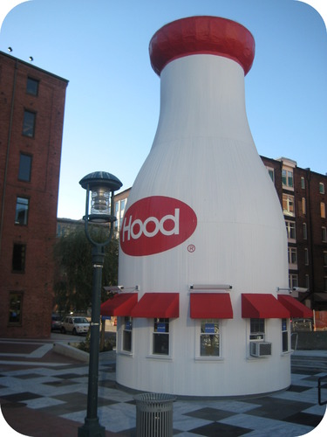
Got milk?
Milk is one of the basic foods needed for good nutrition, especially for growing children. It contains vitamins and minerals necessary for healthy development. Unfortunately, milk and other dairy products also contains lactose, a carbohydrate that can make some people very ill. Lactose intolerance is a condition in which the lactose in milk cannot be digested well in the small intestine. The undigested lactose then moves into the large intestine where bacteria attack it, forming large amounts of gas. Symptoms of lactose intolerance include bloating, cramps, nausea, and vomiting. Often, the individual will outgrow this problem. Avoidance of foods containing lactose is recommended for people who show signs of lactose intolerance. Since dairy products can provide many vital nutrients, tablets can be taken that provide the needed digestive materials in the small intestine. Lactose-free milk is also readily available. Source: Ck-12.com. (2013, January, 26) Disaccharides. Retrieved from
http://www.ck12.org/chemistry/Disaccharides/lesson/Disaccharides/r13

